The following links are for Type to Learn 4 on your home computer.

Choose Windows or Mac download. (Takes some time to download)

Full TTL4 Application - Mac - Web Version v1.2.1
(See instructions below)

Full TTL4 Application - Windows - Web Version v1.2.1
With Windows you need to unzip the file using winzip. If you don’t have winzip follow the directions below.

Instructions
Download and install WinRAR or WinAce (see Resources). Follow the onscreen instructions. A restart of the PC may be necessary.

Go to the WinZip file folder. Right-click on the file. You will have three options, "Extract Files," "Extract Here" and "Extract To (File Name)." To unzip the files to a different folder, use the "Extract To (File Name)" option. The application will extract the files.

Wait until the files unzip. A window will appear showing the process. This takes about 5 minutes for larger file sizes. The window may close automatically. If not, click the top "X" button. Open the folder in which you directed the files to unzip. Then you can explore the extraction of the WinZip file.

1. Once downloaded on you computer run the installer.

2. Launch the application

3. A screen will come up asking for a username and password. (Your child or child’s teacher should know this) On first launch it will also ask for an account code. Enter 142931. You should not have to do this again. At this point students should know what to do.

****If you are using a Mac, you might get a message that says can’t install unless you downloaded from the App store. If this is the case follow directions below.

Go into System Preference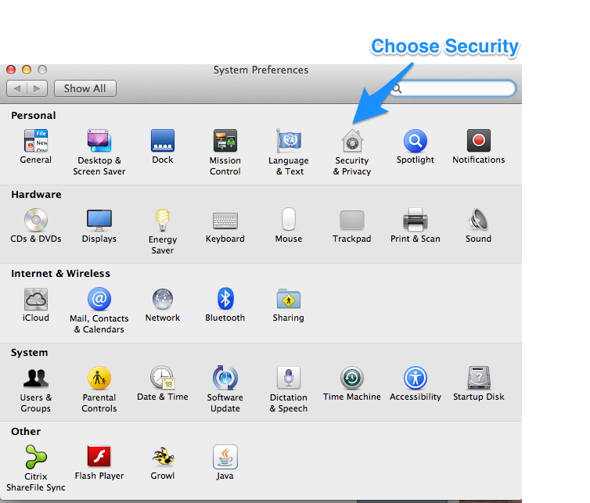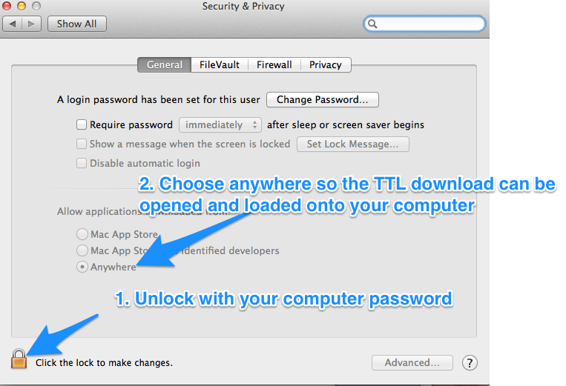
Once completed. Try to complete installation.

